Integration of Git with Eclipse

In this module, we will learn how to import files from remote repository to our workspace or local repository and vice versa.

Importing a project from Git repository

- To import projects, from project explorer select import
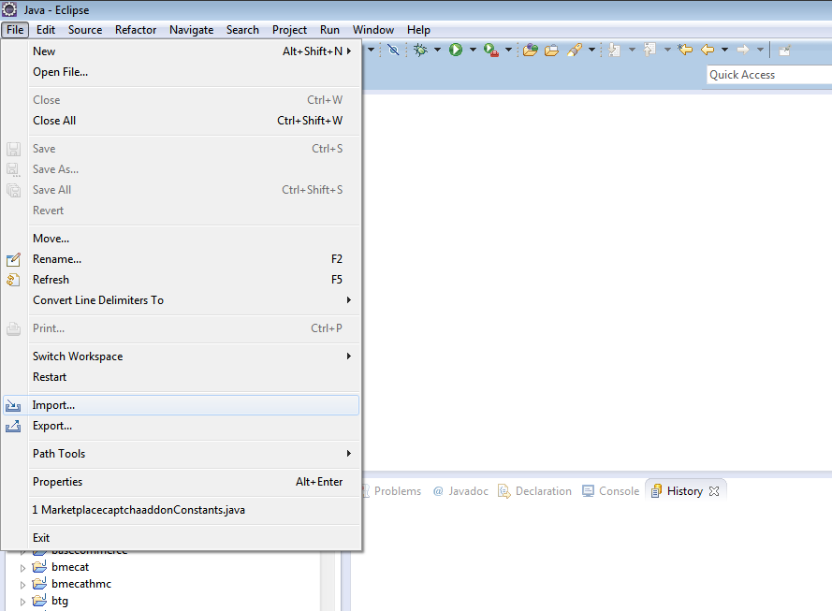

- Choose Git → Projects from Git

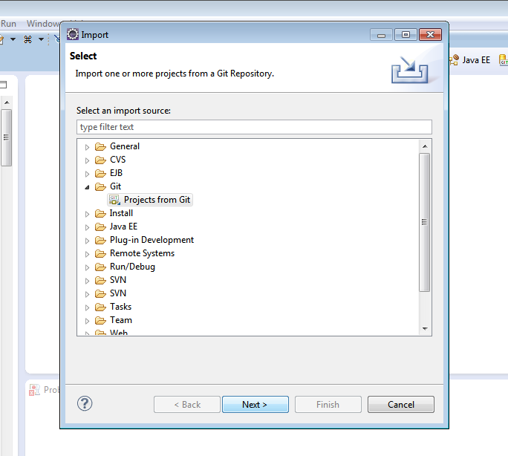

- Select URI where we shall put the address of remote repository.
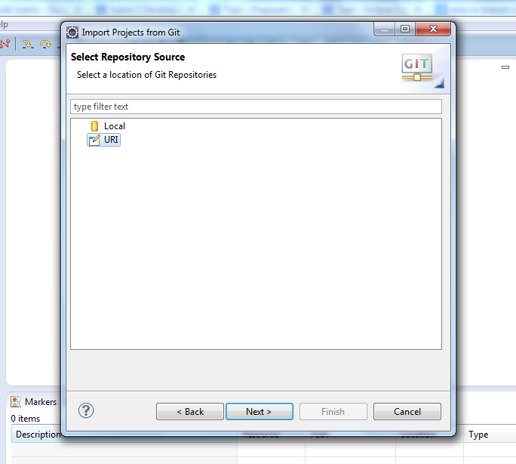

- Enter URI for source Git repository and provide username and password and select next.

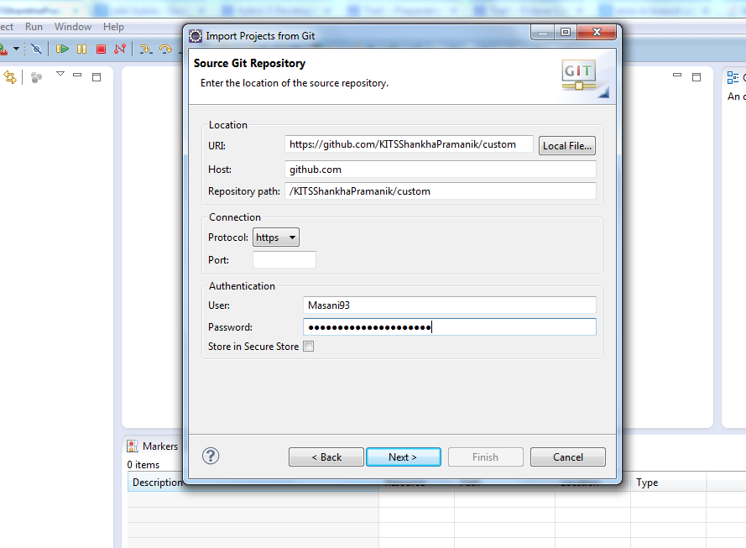

- Select the appropriate branch and click next.
In this example, Iteration1 branch is selected since only projects from branch Iteration1 is needed to be imported.
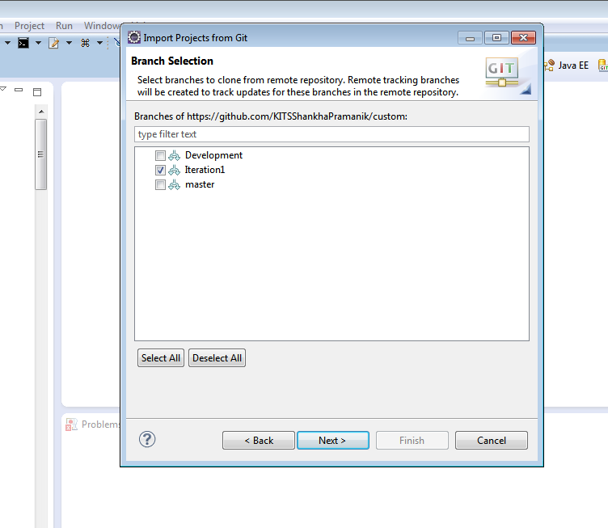

- Select path for local repository. Select path from hybris commerce suite up to its bin folder.
This bin folder holds all the extensions provided by hybris commerce suite. There is a folder called platform, inside which all the necessary files are located to build the file.
We shall be working the extensions provided. All the new files created should be under a folder named “custom” since at build time, eclipse automatically will look for custom folder.
Hence the path of the local repository should be from hybris commerce suite up to its bin folder and repository name should be custom.

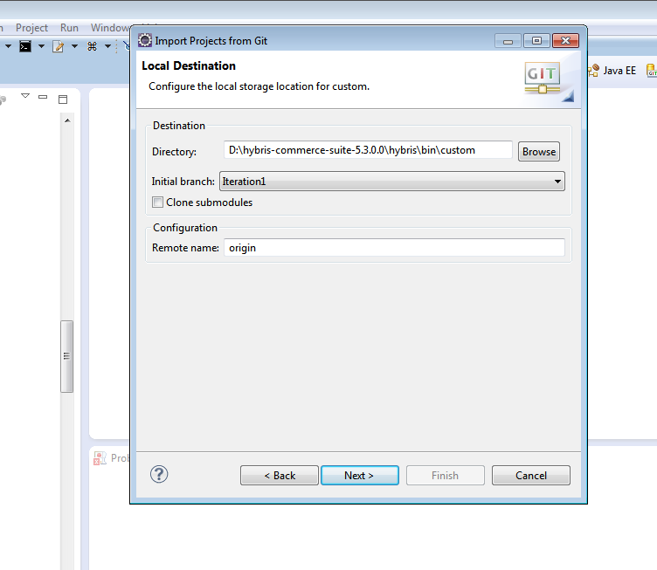

7. wait till all the objects are received.

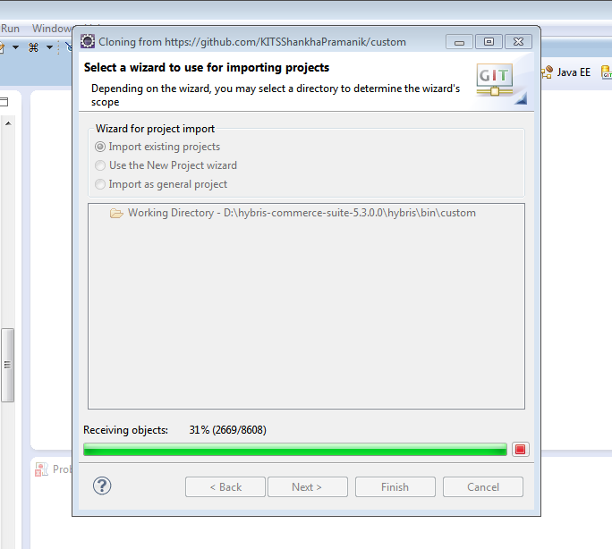

- If there are some other projects present, then wizard should be Import existing project. Otherwise import as general project can be selected.

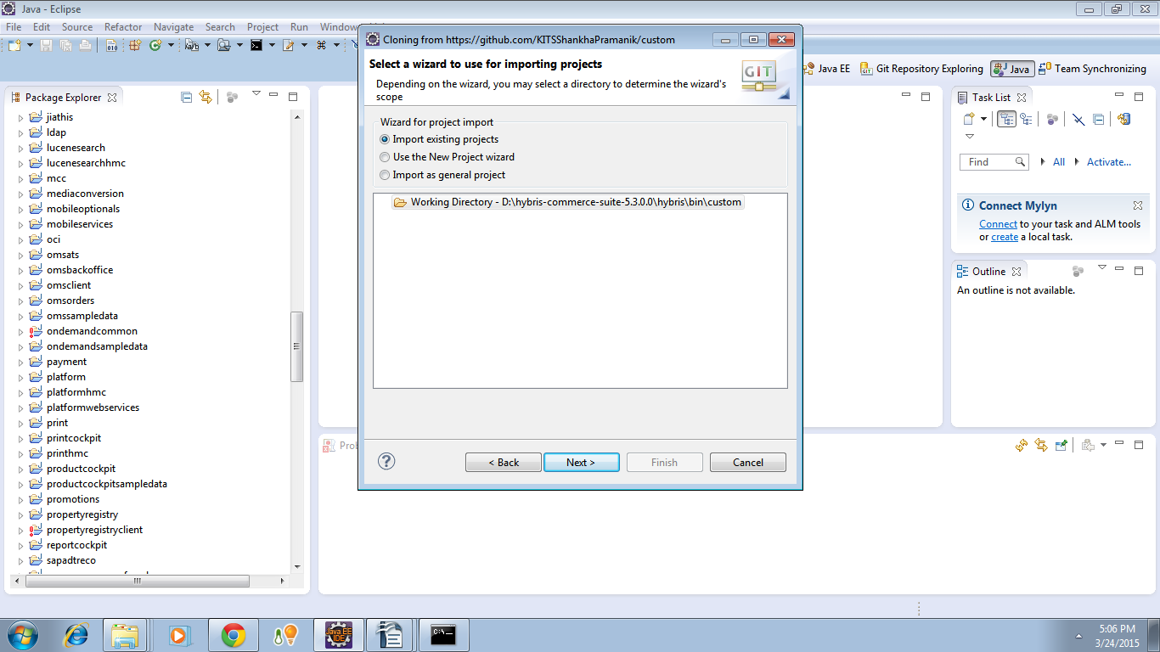

- Only the projects which are to be imported are marked as selected and finish is clicked.

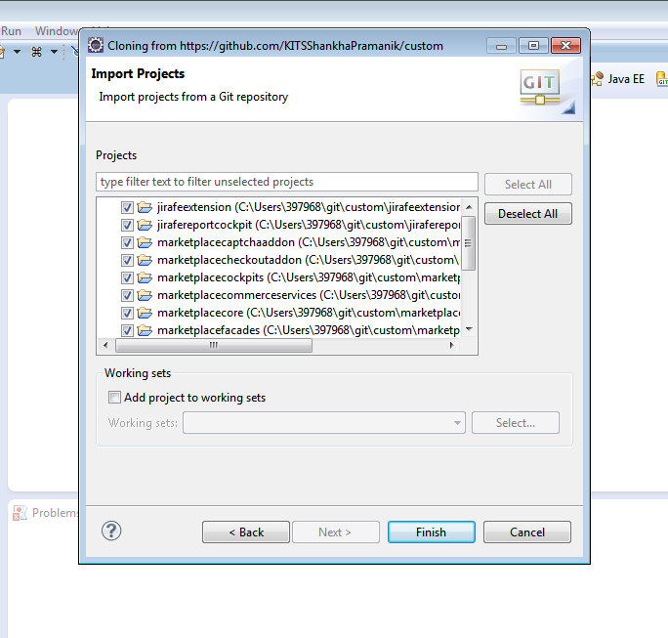
10. Projects are successfully imported. Each project name is trailed by directory name [custom] and branch repository name [iteration 1]

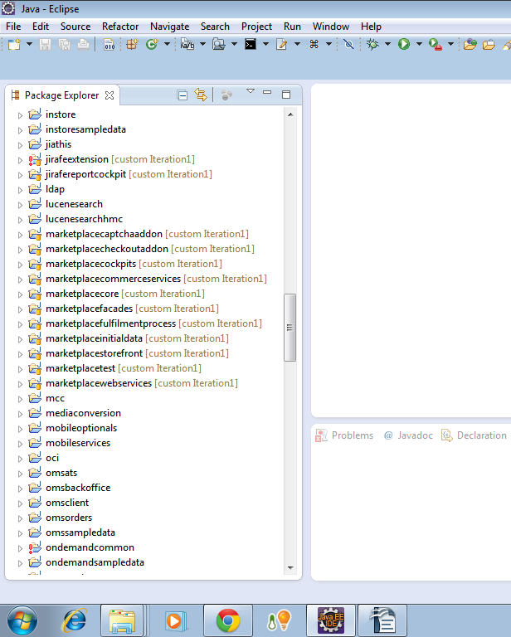

- As clearly shown, the custom folder is created inside bin.

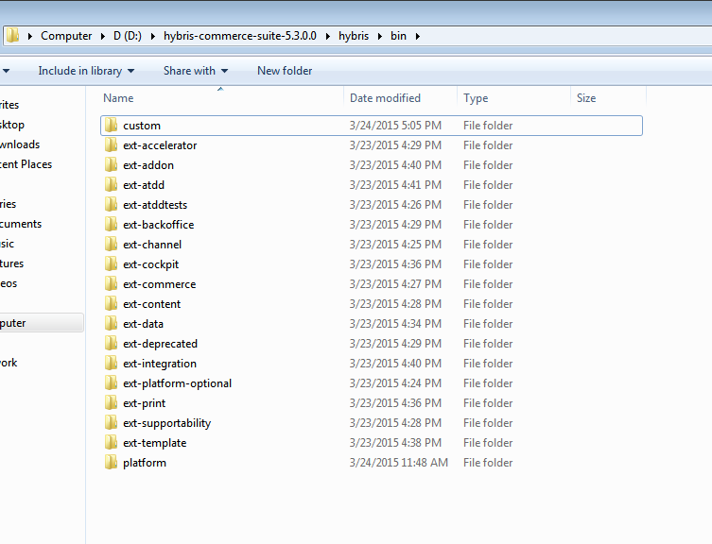

- Inside custom all the projects are imported.

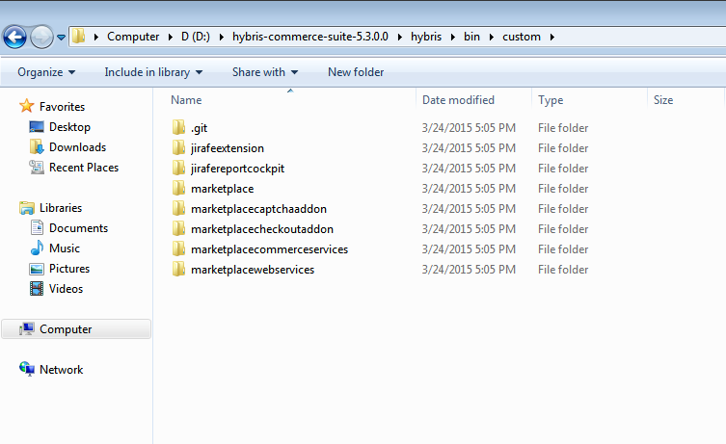

After the projects are imported, eclipse should be ready to build them. Build is done from platform.
Within platform switch to command line and type ant clean all to build. Make sure build is successful.

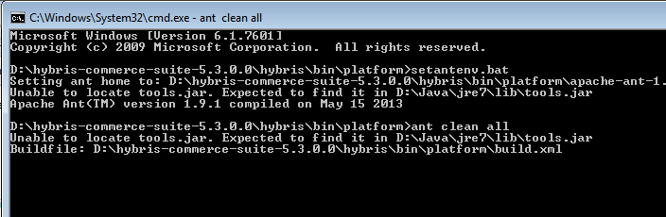

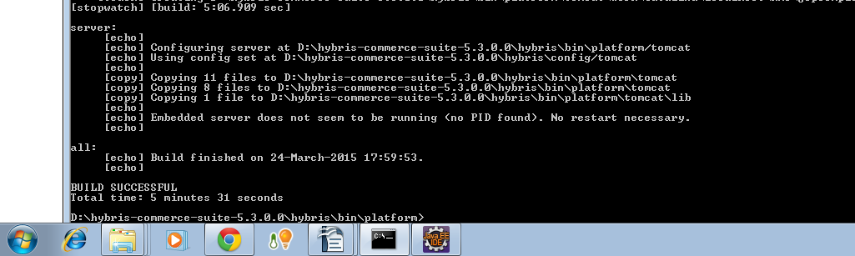

A successful builds indicates that checkout of all the files from remote repository is done correctly to local repository.

13. After checkout, another pull operation is executed. This is a trial attempt, if no change is made in files, after pulling nothing should be updated.

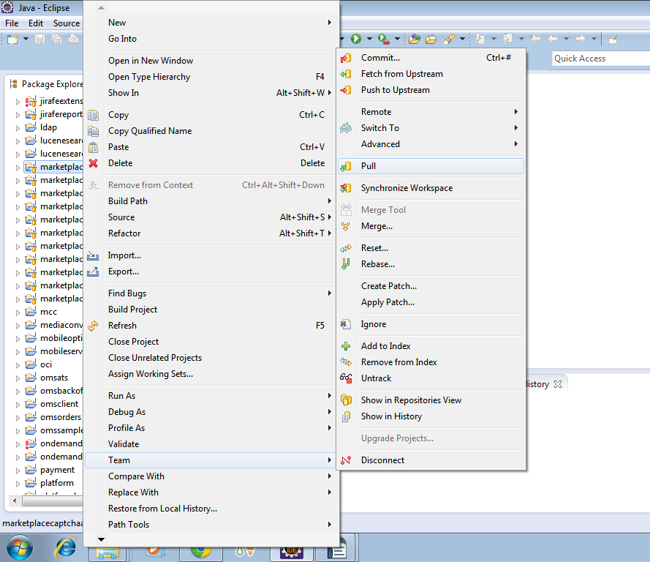

14. Operation is being processed.

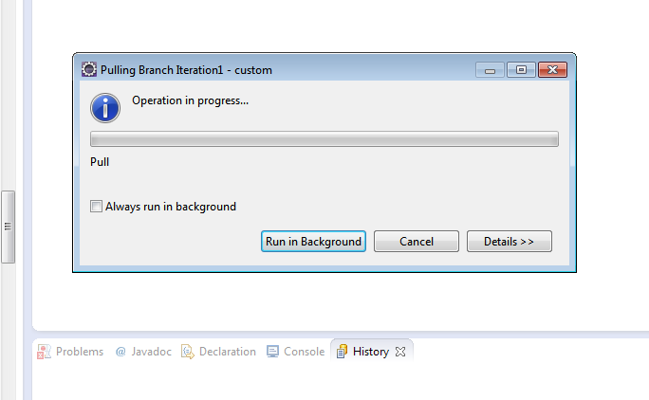

15. No new files are pulled since everything is already up to date.

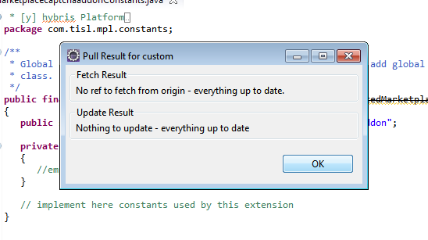

Pushing files to Repository

16. A change is made in a particular file. A comment is added at the end of file.

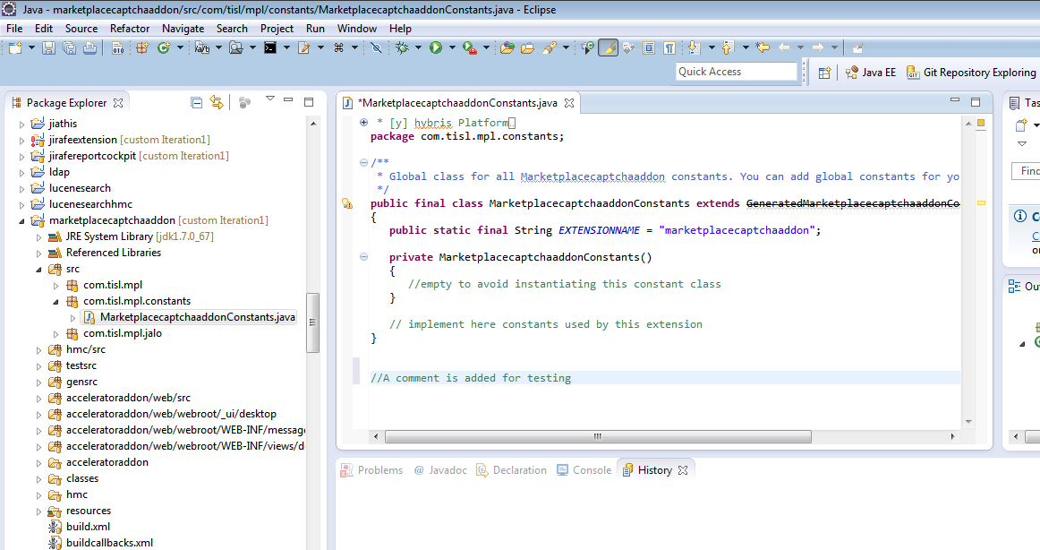

- After making necessary changes, we need to commit to make the change permanent.
Right click on the Project → Team → Commit.

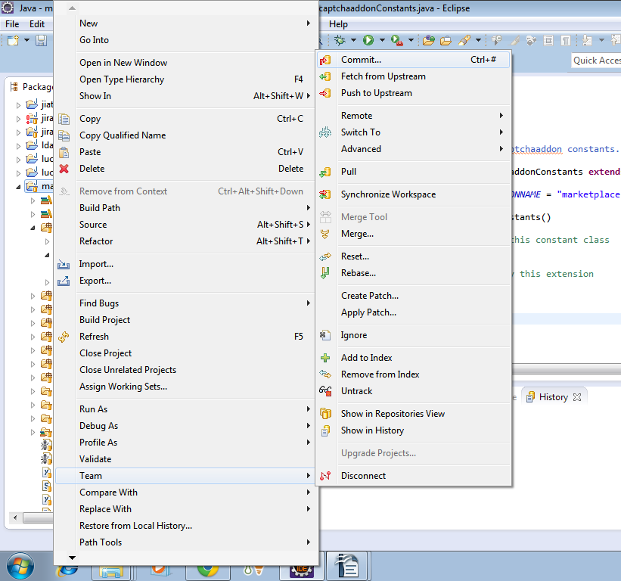

18. A meaningful comment is added which describes the change.
Files where changes are made are selected and “comment and push” is selected. By pushing, the updated files are being sent to the remote repository.

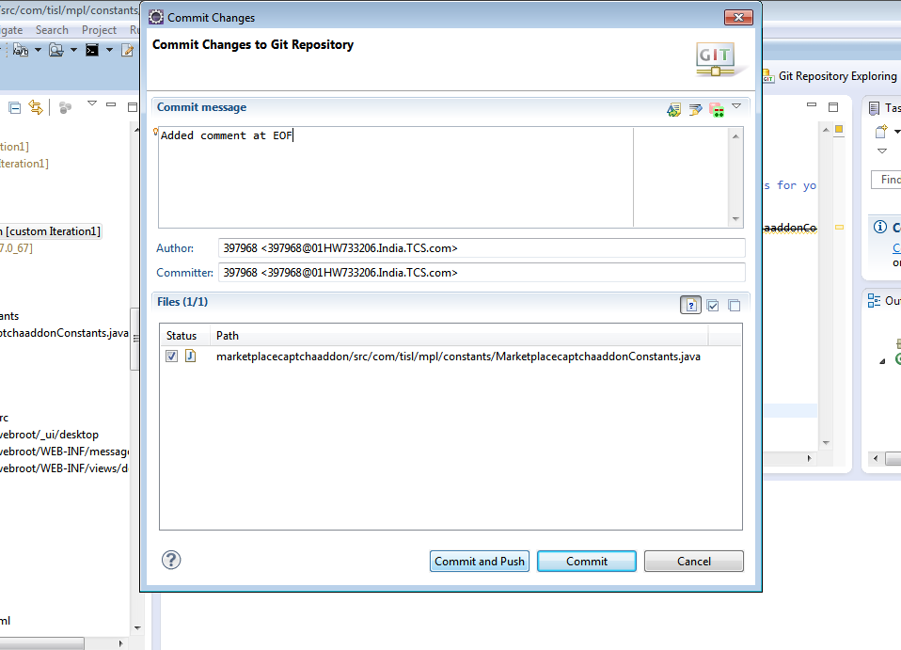

- Push to remote repository is on process.
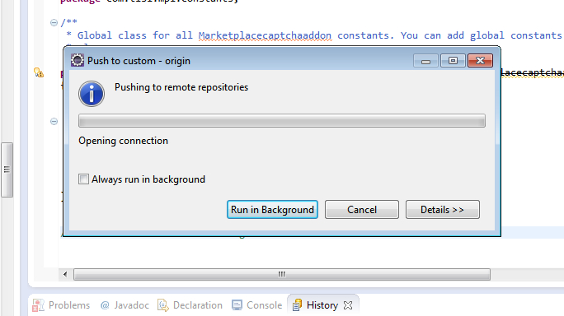

- Since the files are stored at the branch where they already are, hence no configuration is needed. Therefore Ok is selected.
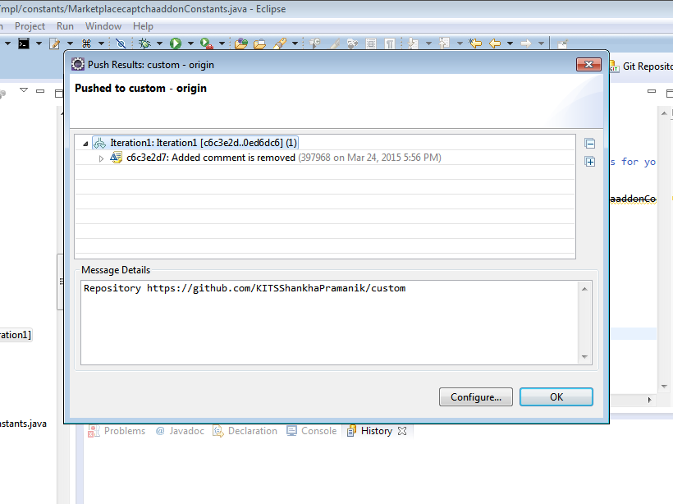

21. Changes are reflected at remote repository.
In this example, project marketplaceaptchaaddon is updated 6 minutes ago.

